How to Make a Graph
Follow directions CAREFULLY!!!!

Step 1:
Go to this website.
https://nces.ed.gov/nceskids/createagraph/default.aspx?ID=fc1f1fcd12f7495aa6d03143a7cedbe4

Step 2:
Select Bar Graph
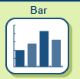

Step 3:
Click on the Data tab.
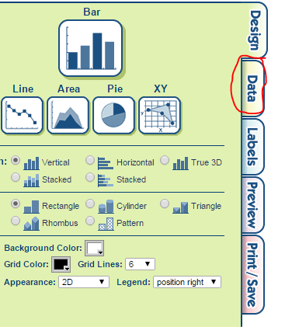

Step 4:
Enter information to MATCH the picture below. Your GRAPH TITLE, STUDENT NAMES and VALUES will be different and match your HW graph.
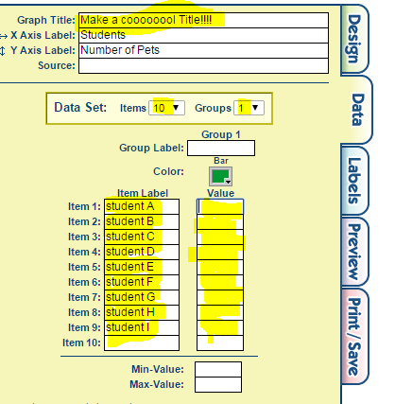
Step 5:
Click on Preview tab to see what your graph will look like. Does it match your hand-drawn graph? Then go to Step 6!
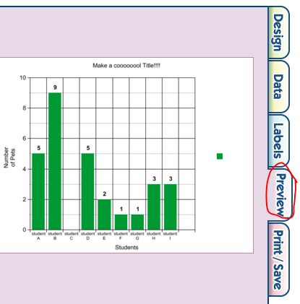

Step 6:
Click on the Print/Save tab. Type Mrs. Dongilla’s email address in the box and click on the Send button! 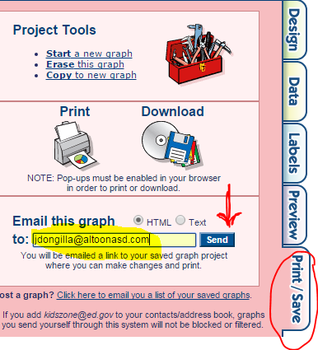s

CONGRATULATIONS! You have created your first digital graph!

